
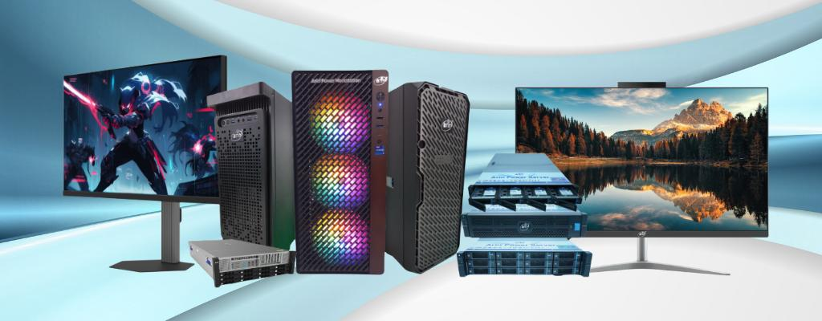
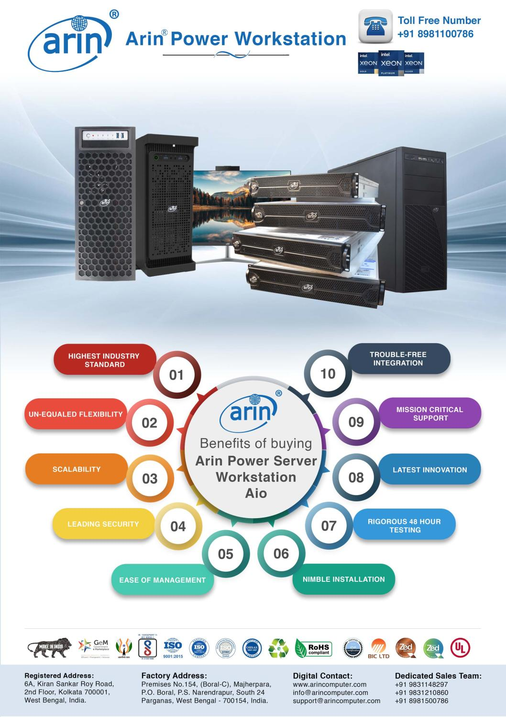


Features and Specifications – Arin® Power Workstation
Model: AR-WS5000(A50)


 | Processor:  Support for the 14th, 13th, and 12th Generation  Intel® Core™ processors,  Socket LGA-1700 supported
 | Memory:  4 x DIMM, Max. 128GB, DDR5 ECC /Non-ECC Un-Buffered Memory
 | Drive bays:  Support up to 4 SATA HDD/SSD Drives  2 x 3.5in SATA HDD/SSD Bays  2 x 2.5in SATA HDD/SSD Bays
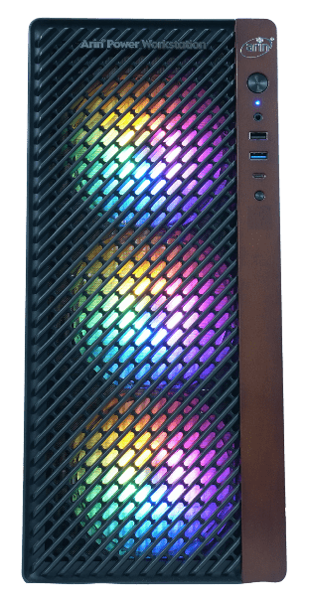
 | Power Supply (PSU):  1050W 80 Plus Gold Power Supply  1200W Platinum 80 Plus Power Supply (Optional)  1600W / 2000W Titanium 80 Plus Power Supply (Optional)
 | OS Supported:  Microsoft Windows 10 Pro 64Bit  Microsoft Windows 11 Pro 64 Bit  Red Hat Enterprise Linux
 | Graphics:  Intel® UHD Graphics 770
 | Chipset:  Intel® B760 Chipset
 | Warranty:  3 Yrs. Onsite Advance Replacement Warranty Across India.
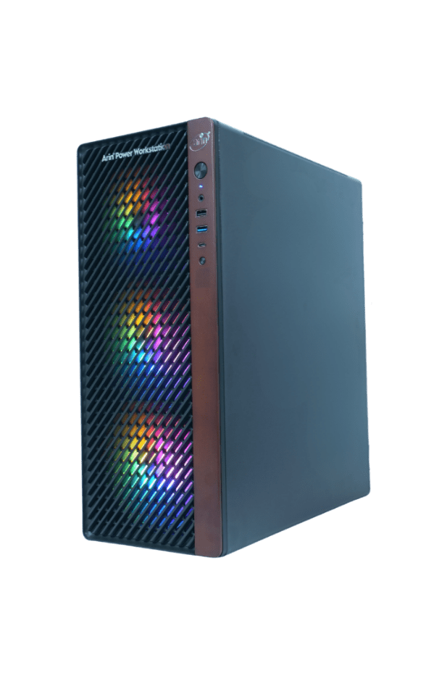
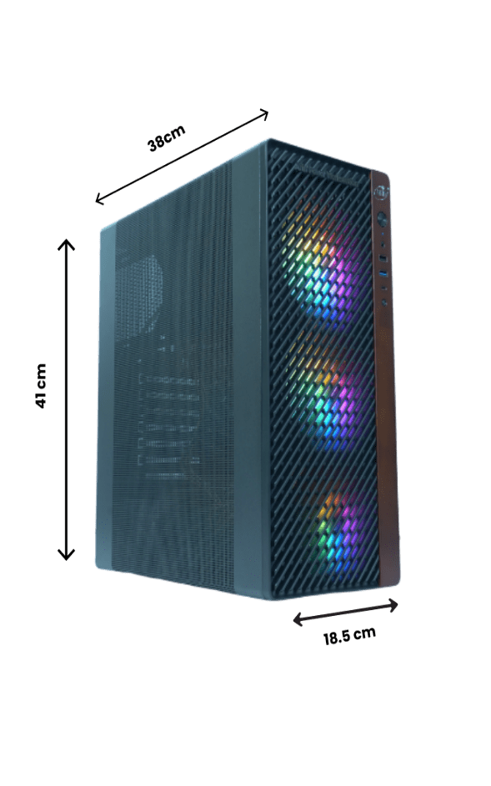






Features and Specifications – Arin® Power Workstation
Model: AR-WS5000(A50)
Features | Technical specifications
Form Factor | Tower
Processor | 1 x Intel Core i9 14th Gen 14900KS (36 MB cache, 24 cores, 32 threads,2.40 GHz to 6.20 GHz,)
Chipset | Intel® B760 Chipset
Memory | 4 x DIMM, Max. 128 GB, DDR5 Non-ECC Un-Buffered Memory  64 GB DDR5 (2 x 32 GB) DIMM 4800 MHz Installed
Storage controllers | On-Board controller with 4 Ports supports RAID level 0, 1, 5, 10
Storage | 1 x 2 TB NVMe, SSD
Graphics | 1 x NVIDIA RTX 4500 ADA Generation 24GB
Networking | Intel® Wi-Fi with 6E AX211  802.11ax 2x2 with Bluetooth® M.2 Combo
Power supplies | 1 x 1050W 80 Plus Gold Power Supply
TPM | 1 TPM Header  Trusted Platform Module (TPM) 2.0 (Optional)
Security | Trusted Platform Module 2.0 (Optional)  Secure Boot






Features and Specifications – Arin® Power Workstation
Model: AR-WS5000(A50)

Features | Technical specifications
Internal I/O & Ports | Dual LAN with Gigabit Ethernet Controller  1x 1 GbE BaseT Ports  1 x 2.5 GbE BaseT Ports  Intel® controller for 4 SATA3 (6 Gbps) ports; RAID 0,1,5  1 x VGA D-Sub Connector port  Rear USB (Total 8 ports)  - 2 x USB 3.2 Gen 2 ports (1 x Type-A, 1 x Type-C®)  - 4 x USB 3.2 Gen 1 ports (4 x Type-A)  - 2 x USB 2.0 ports (2 x Type-A)  Front USB (Total 7 ports)  - 1 x USB 3.2 Gen 2x2 connector (supports USB Type-C®)  - 1 x USB 3.2 Gen 1 header supports additional 2 USB 3.2 Gen 1 ports  - 2 x USB 2.0 headers support additional 4 USB 2.0 ports 1 x PCIe 3.0 x1 (supports x4 mode)  - 2 x PCIe 5.0 x16 slots (support x16 or x8 / x8 mode)  - 2 x PCIe 3.0 x16 slots (supports x4 mode)  - 1 x PCIe 3.0 x1 slot  M.2 Interface: 2 PCIe 4.0  M.2 Form Factor: 2280/22110  M.2 Key: M-Key
Display | 27 inches,FHD,Flat Panel,IPS
Peripherals | Standard Wired Keyboard and Optical Scroll Mouse
OS Pre-installed | Windows 11 Pro
Recommended support and services | Choose arin® for critical systems hardware and software support for your Power Workstation solution. Consulting and deployment offerings are also available. Contact your arin™ representative today for more information.
Warranty | 3 Years Onsite Warranty.




Warranty Call Log Process
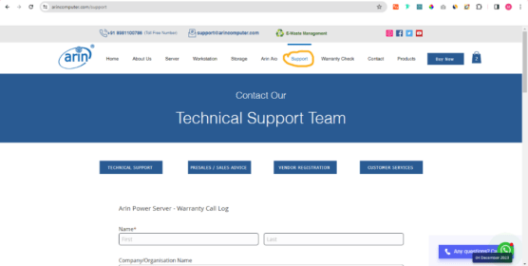
Step 1: Go to https://www.arincomputer.com/support.

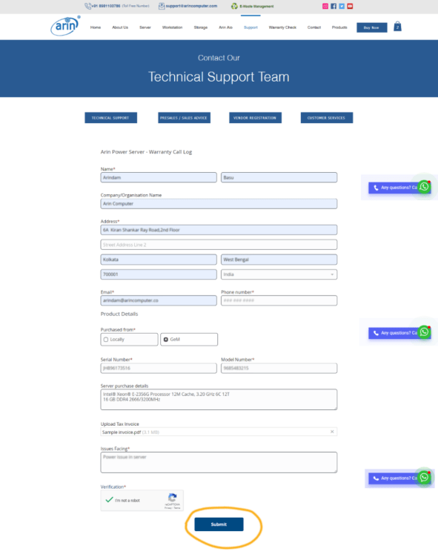
Step 2: Fill-up the “Warranty Call Log” form & Submit.



Warranty Check Process

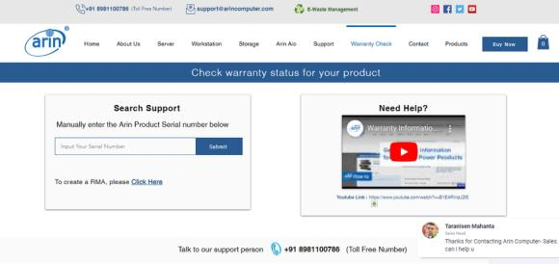
Step 1: Go to https://www.arincomputer.com/warranty.

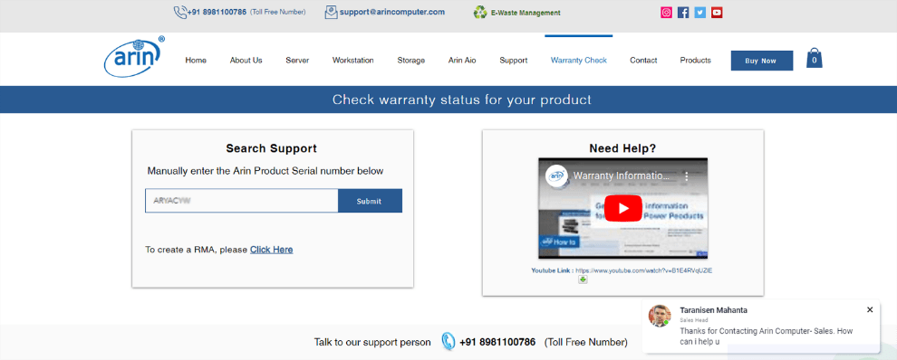
Step 2: Input your “Arin Product Serial Number” into the Search Bar.

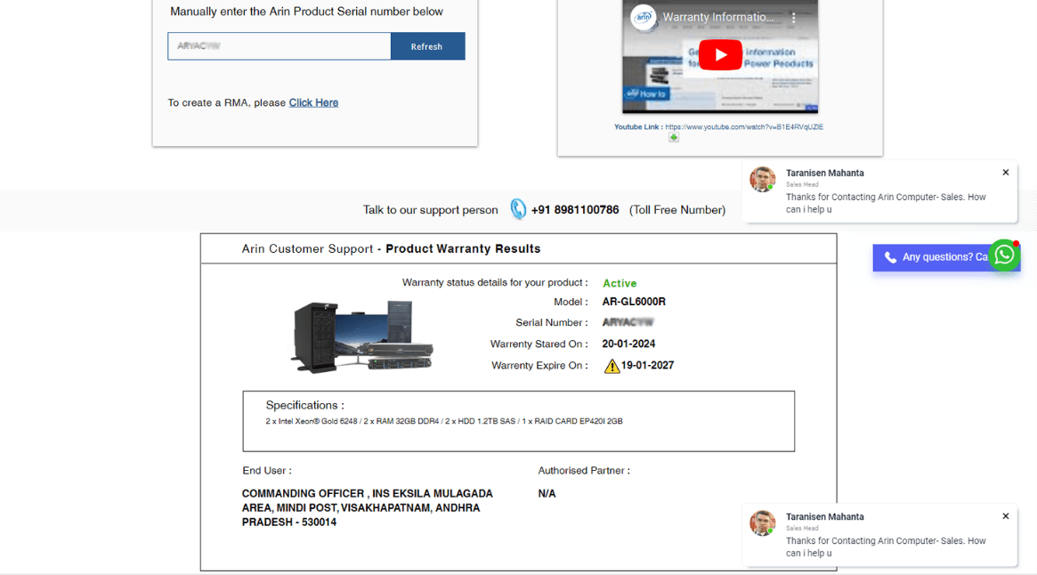
Step 3: Check your Warranty Details here.



