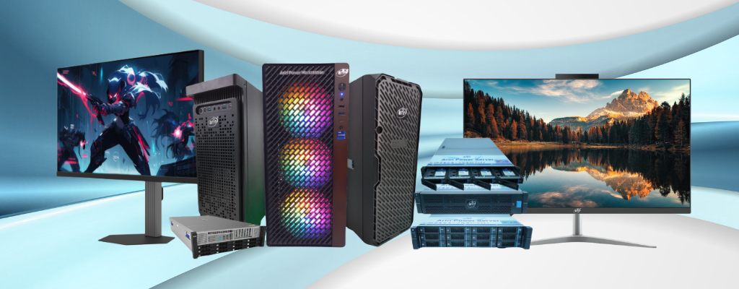

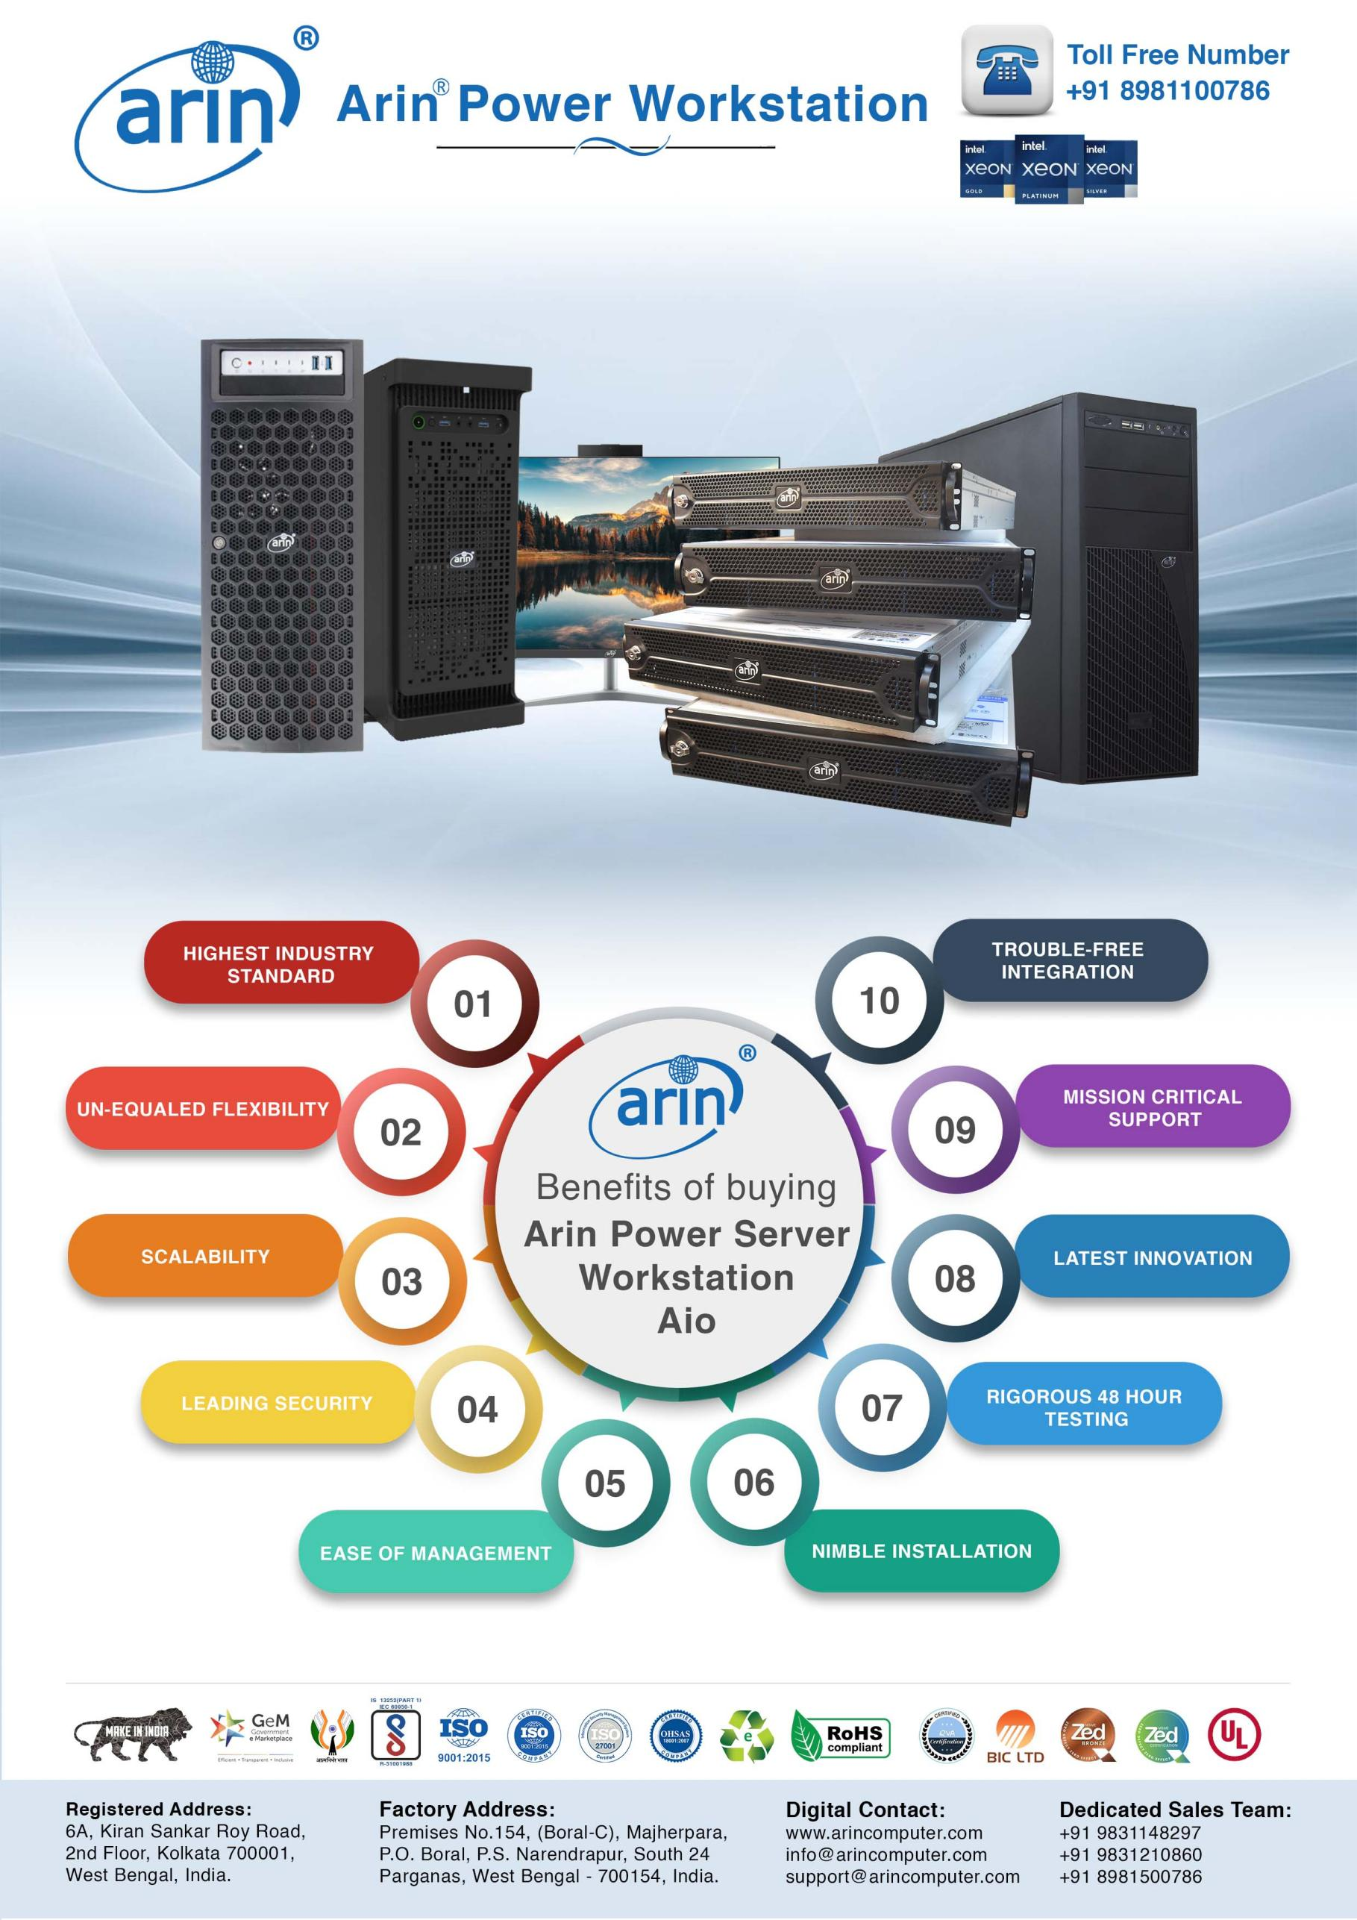

Features and Specifications – Arin® Power Workstation
Model: AR-WS5000(A50)




 | Processor:  Support for the 14th, 13th, and 12th Generation  Intel® Core™ processors,  Socket LGA-1700 supported
 | Memory:  4 x DIMM, Max. 128GB, DDR5 ECC and Non-ECC Un-Buffered Memory
 | Drive bays:  Up to 4 drive bays SFF/LFF  Support up to 4 SATA/SAS HDD/SSD Drives
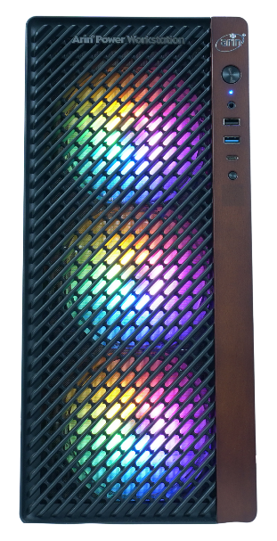
 | Power Supply (PSU):  550W 80 Plus Gold Power Supply  1200W Platinum 80 Plus Power Supply (Optional)  1600W / 2000W Titanium 80 Plus Power Supply (Optional)
 | OS Supported:  Windows 11 Pro 64 Bit  Red Hat Linux 9.0 64 Bit  Ubuntu® LTS 24.04 64 Bit
 | Graphics:  NVIDIA A400 4GB
 | Chipset:  Intel® B760 Chipset
 | Warranty:  3 Yrs. Onsite Advance Replacement Warranty Across India.
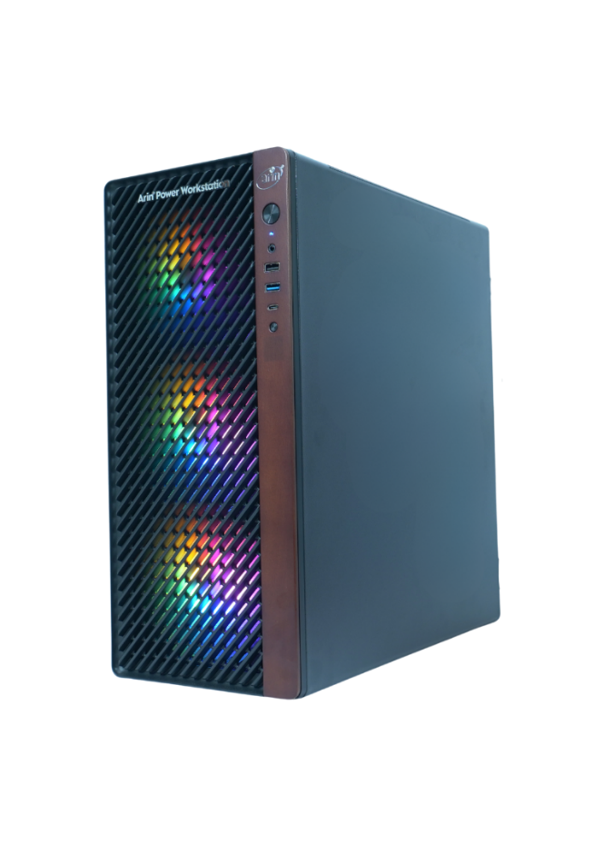
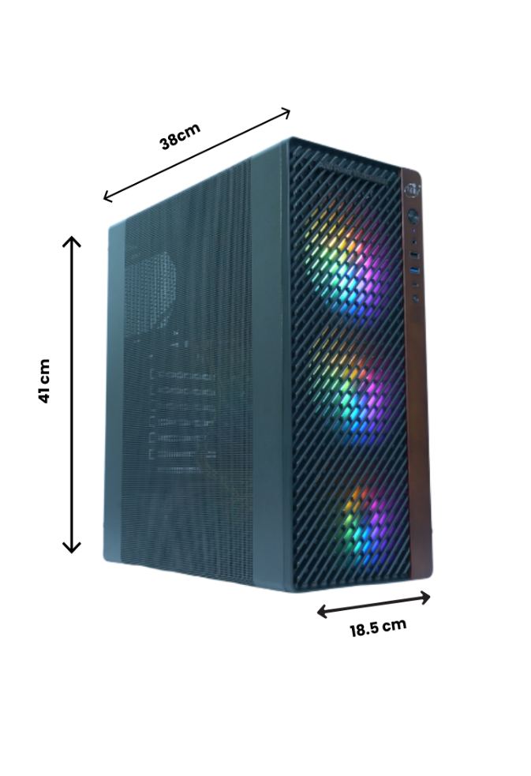






Features and Specifications – Arin® Power Workstation
Model: AR-WS5000(A50)

Features | Technical specifications
Form Factor | Tower
Processor | Intel® Core™ I9 14900KS (24 Cores,32 Threads, Core Base Frequency up to 6.20 GHz, 36M Cache, Processor Base Power 150 W)
Chipset | Intel® B760 Chipset
Memory | 4 x DIMM, Max. 128GB, DDR5 ECC and Non-ECC Un-buffered Memory  64 GB DDR5 (2 x 32 GB) DIMM 4800 MHz Installed
Storage controllers | On-Board controller with 4 Ports supports RAID level 0, 1, 5, 10
Primary Storage | 1 x 1 TB NVMe SSD
Graphics | 1 x NVIDIA A400 4GB
Display | 27” LED Monitor,IPS,Flat Screen
CPU Cooling | L120 Liquid Cooling for Robust CPU Cooling
Power supplies | 550W 80 Plus Gold Power Supply
Bluetooth | Wi – fi 6 AX 200 & BT 5.3
TPM | 1 TPM Header  Trusted Platform Module (TPM) 2.0
Security | Trusted Platform Module 2.0  Secure Boot






Features and Specifications – Arin® Power Workstation
Model: AR-WS5000(A50)

Features | Technical specifications
Internal I/O & Ports | Dual LAN with Gigabit Ethernet Controller  1x 1 GbE BaseT Ports  1 x 2.5 GbE BaseT Ports  Intel® controller for 4 SATA3 (6 Gbps) ports; RAID 0,1,5  1 x VGA D-Sub Connector port  Rear USB (Total 8 ports)  - 2 x USB 3.2 Gen 2 ports (1 x Type-A, 1 x Type-C®)  - 4 x USB 3.2 Gen 1 ports (4 x Type-A)  - 2 x USB 2.0 ports (2 x Type-A)  Front USB (Total 7 ports)  - 1 x USB 3.2 Gen 2x2 connector (supports USB Type-C®)  - 1 x USB 3.2 Gen 1 header supports additional 2 USB 3.2 Gen 1 ports  - 2 x USB 2.0 headers support additional 4 USB 2.0 ports 1 x PCIe 3.0 x1 (supports x4 mode)  - 2 x PCIe 5.0 x16 slots (support x16 or x8 / x8 mode)  - 2 x PCIe 3.0 x16 slots (supports x4 mode)  - 1 x PCIe 3.0 x1 slot  M.2 Interface: 2 PCIe 4.0  M.2 Form Factor: 2280/22110  M.2 Key: M-Key
Peripherals | Standard Wired Keyboard and Optical Scroll Mouse
OS ( Factory Pre – Loaded ) | Windows 11 Professional
Recommended support and services | Choose arin® for critical systems hardware and software support for your Power Workstation solution. Consulting and deployment offerings are also available. Contact your arin™ representative today for more information.
Warranty | 3 Year Onsite Warranty.




Warranty Call Log Process
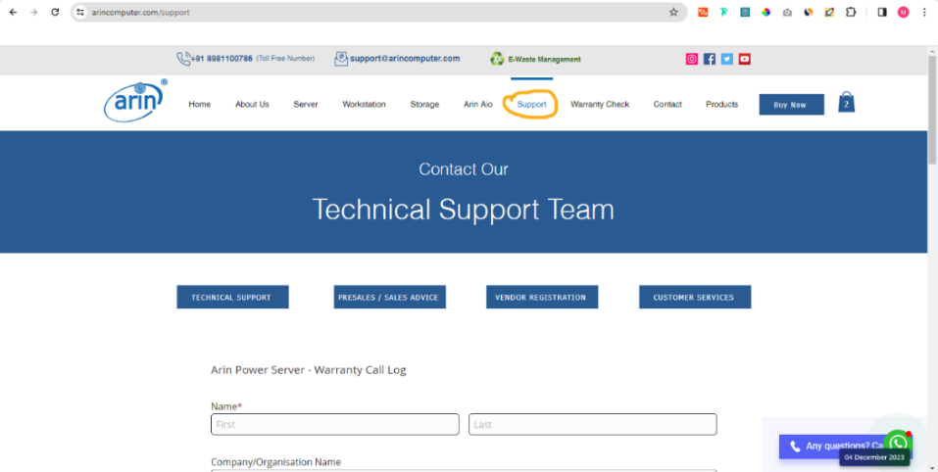
Step 1: Go to https://www.arincomputer.com/support.

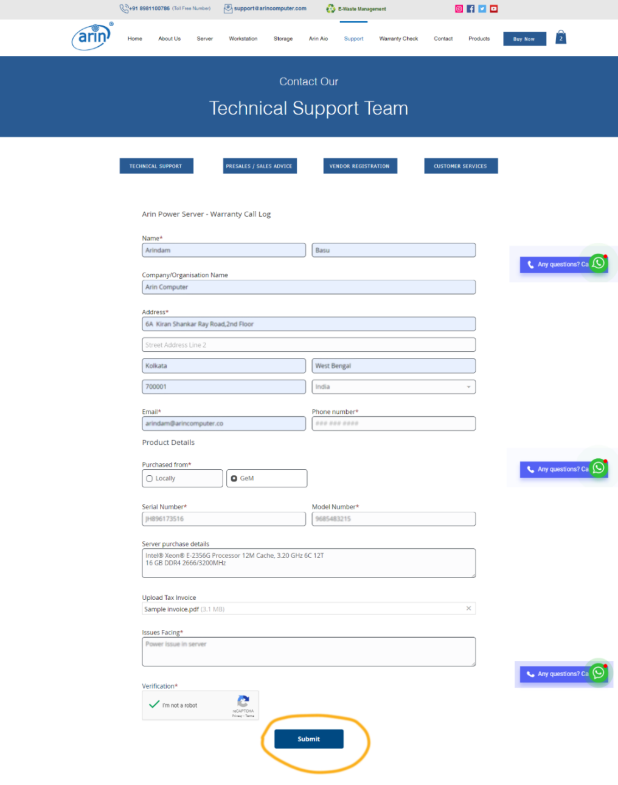
Step 2: Fill-up the “Warranty Call Log” form & Submit.



Warranty Check Process

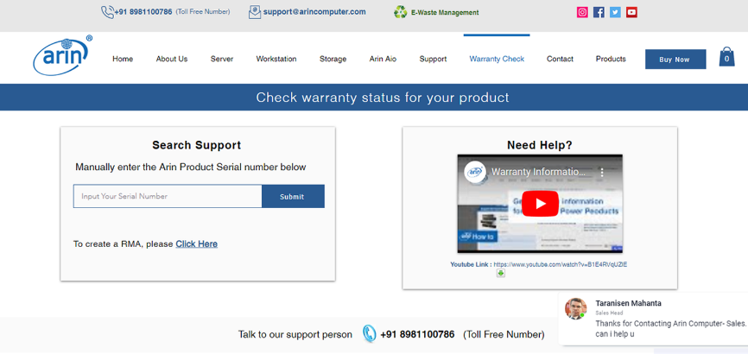
Step 1: Go to https://www.arincomputer.com/warranty.

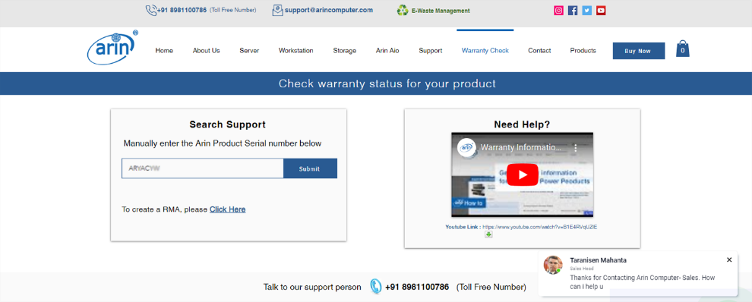
Step 2: Input your “Arin Product Serial Number” into the Search Bar.

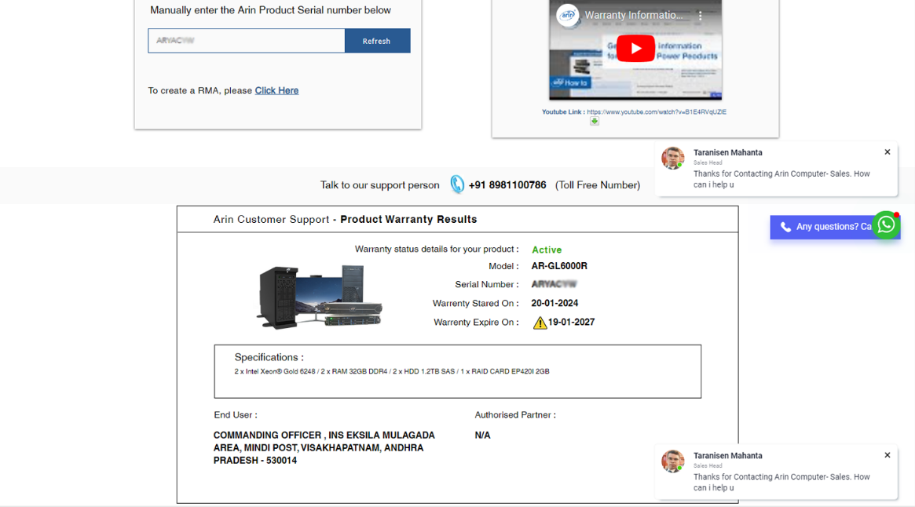
Step 3: Check your Warranty Details here.

